Question : 1
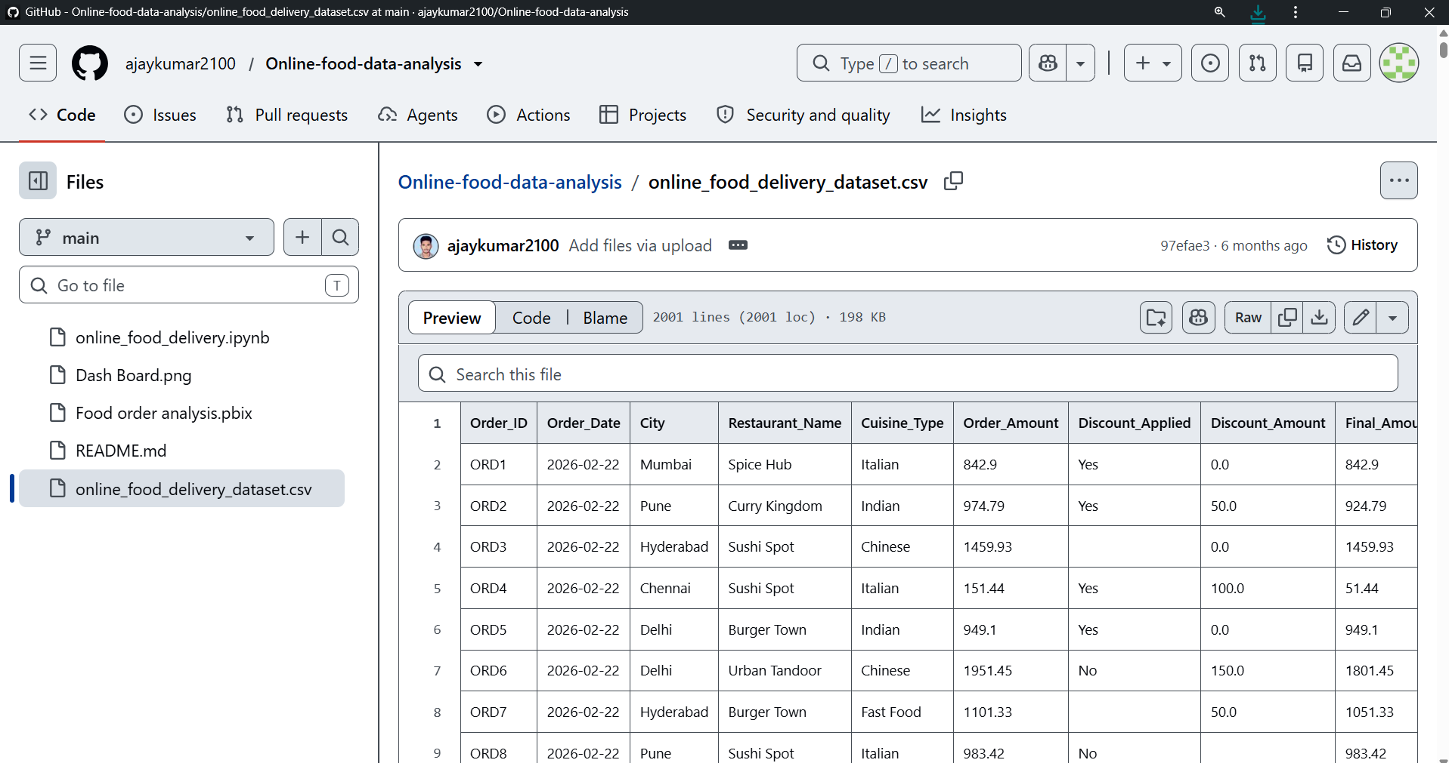
Download a small sample of your recent Zomato order history as a CSV (or create a mock CSV with restaurant names and order dates), then use pandas' duplicated() function to find and print any duplicate orders based on restaurant name and date :

import pandas as pd
df = pd.read_csv("Lib/online_food_delivery_dataset.csv")
duplicates = df[df.duplicated(
subset=["Restaurant_Name", "Order_Date"],
keep=False
)]
print("Duplicate Orders:")
print(duplicates)

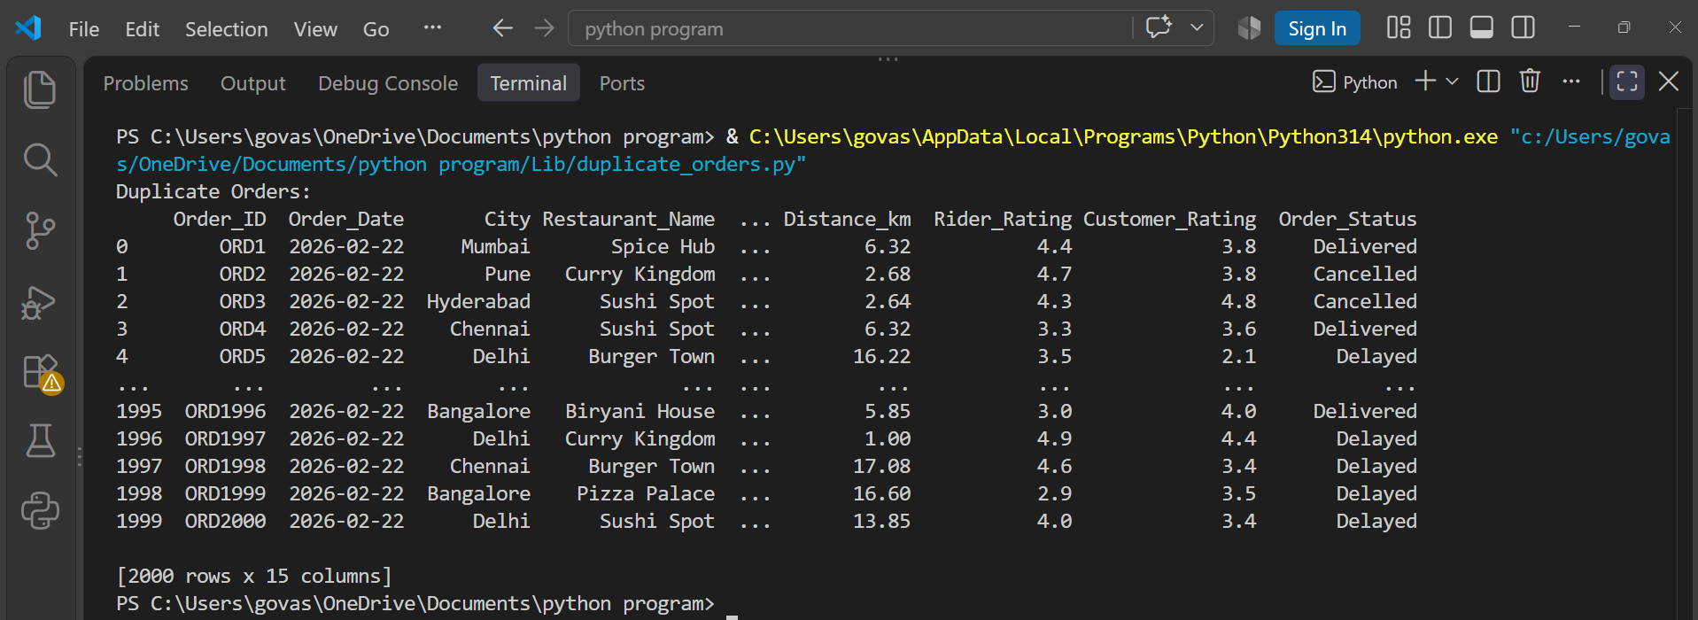
Question : 2
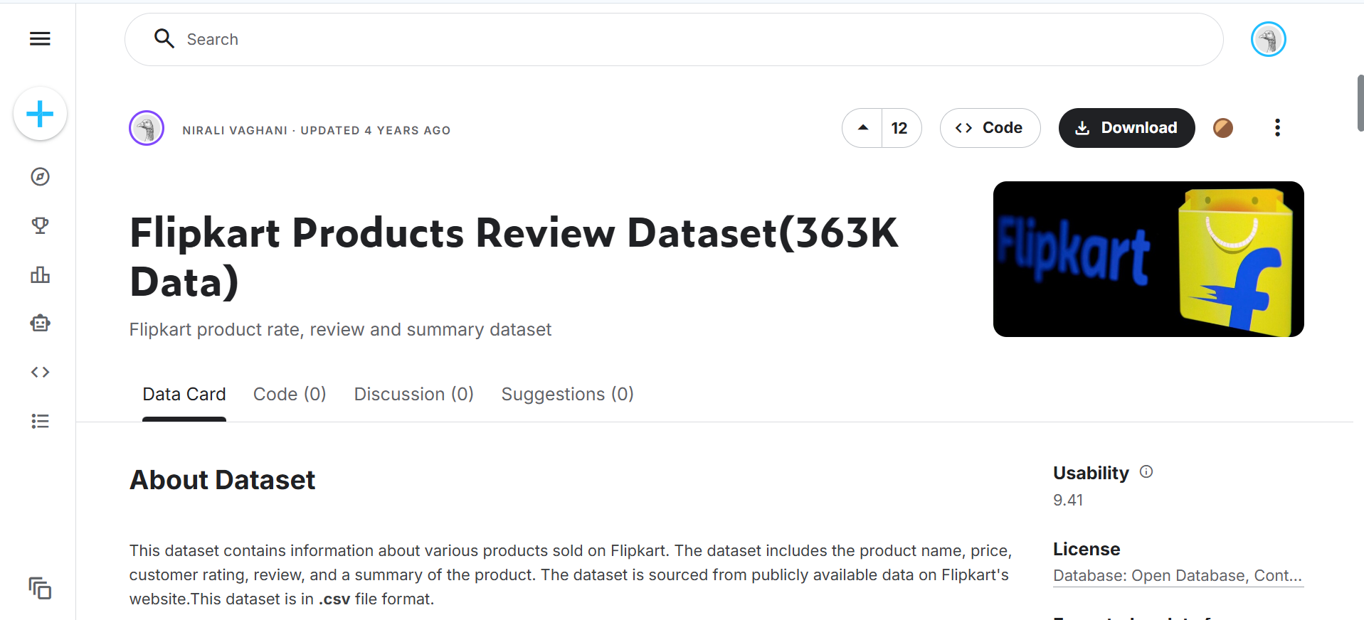
Given a list of Flipkart product reviews with some duplicate entries, use value_counts() in pandas to identify which review texts are repeated most often and display the top 3 most common duplicate reviews :
import pandas as pd
df = pd.read_csv("Lib/Dataset.csv", encoding="latin1")
review_counts = df["Review"].value_counts()
print("Top 3 Most Common Duplicate Reviews:")
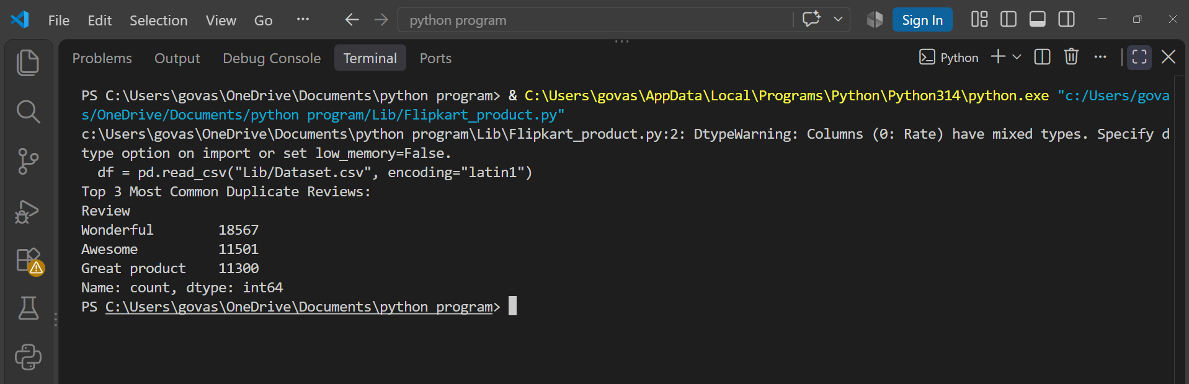
print(review_counts.head(3))

Question : 3
Create a DataFrame with mock data for Spotify playlists, including playlist names and creator usernames, where some rows are exact duplicates. Use drop_duplicates() to remove duplicate playlists and print the cleaned DataFrame :

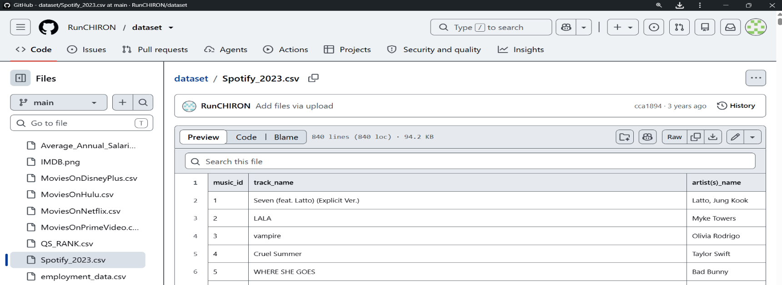
import pandas as pd
df = pd.read_csv("Lib/Spotify_2023.csv")
print("Original rows:", len(df))
cleaned_df = df.drop_duplicates()
print("Rows after removing duplicates:", len(cleaned_df))
print("\nCleaned DataFrame:")
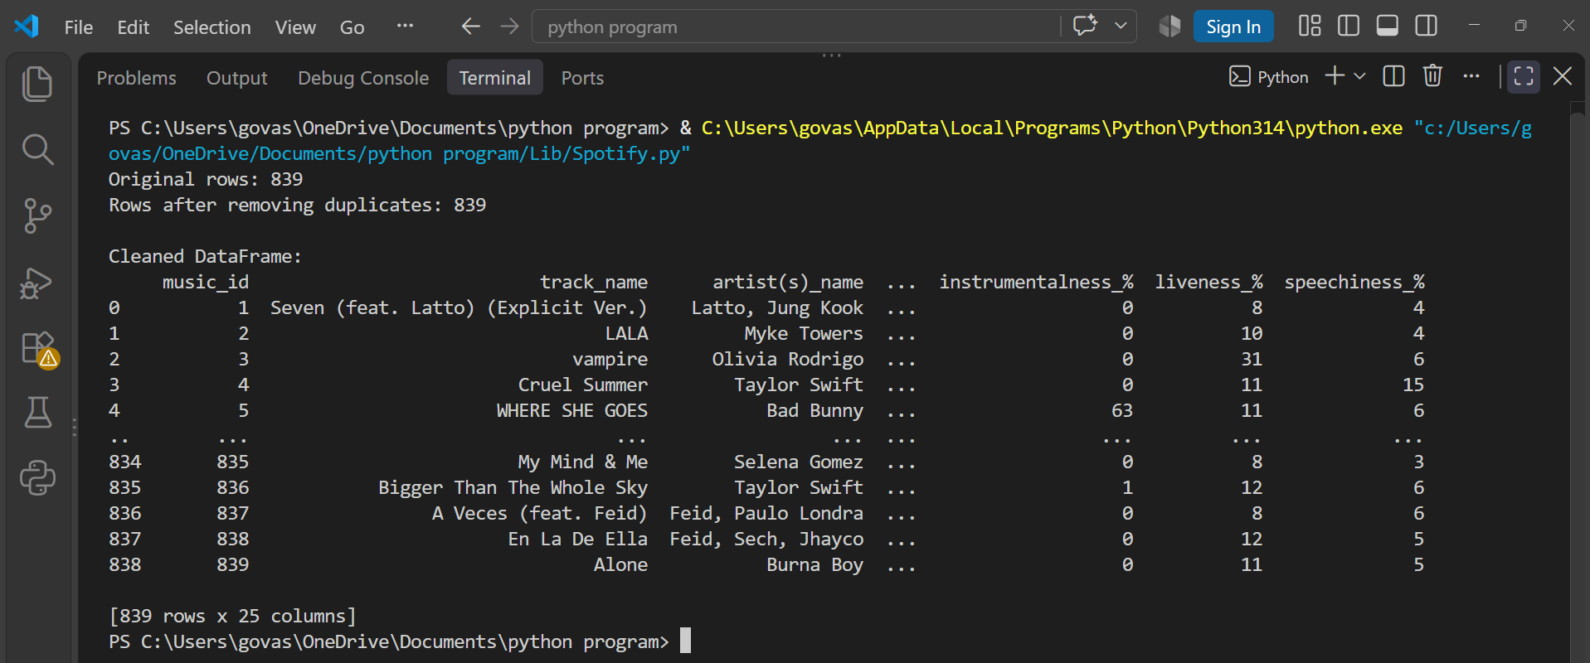
print(cleaned_df)
Question : 4
Suppose you have a DataFrame of Instagram usernames where some entries have typos (like 'insta_queen', 'insta-queen', 'instaqueen'). Use the replace() function to standardize all these variants to 'instaqueen' :

import pandas as pd
df = pd.DataFrame({
"username": ["insta_queen","insta- queen","instaqueen","user123","insta_queen"]})
print("Original DataFrame:")
print(df)
df["username"] = df["username"].replace({
"insta_queen": "instaqueen",
"insta-queen": "instaqueen"})
print("\nStandardized DataFrame:")
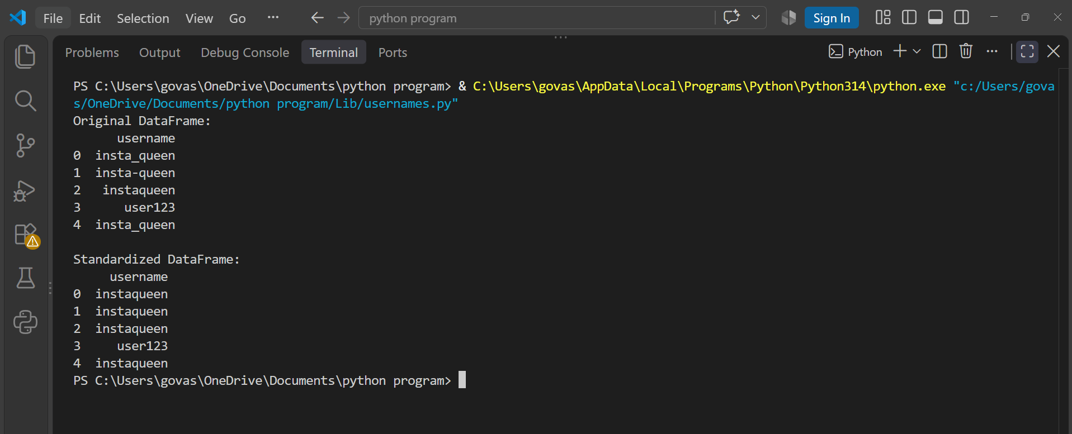
print(df)
Question : 5
You have a DataFrame column for payment status from a Paytm-like app with mixed values: 'Yes', 'yes', 'Y', 'No', 'no', 'N', and some with extra spaces. Write code to unify this column so all paid statuses become 1 and all unpaid statuses become 0, trimming whitespace and fixing capitalization where needed.<br><br><em><strong>Hint:</strong> Use str.strip(), str.lower(), and map/replace methods in pandas : </em>
import pandas as pd
df = pd.DataFrame({
"payment_status": ["Yes"," yes ","Y","No"," no ","N"]})
print("Original DataFrame:")
print(df)
df["payment_status"] = (
df["payment_status"].str.strip().str.lower()
.replace({"yes": 1,"y": 1,"no": 0,"n": 0}))
print("\nStandardized DataFrame:")
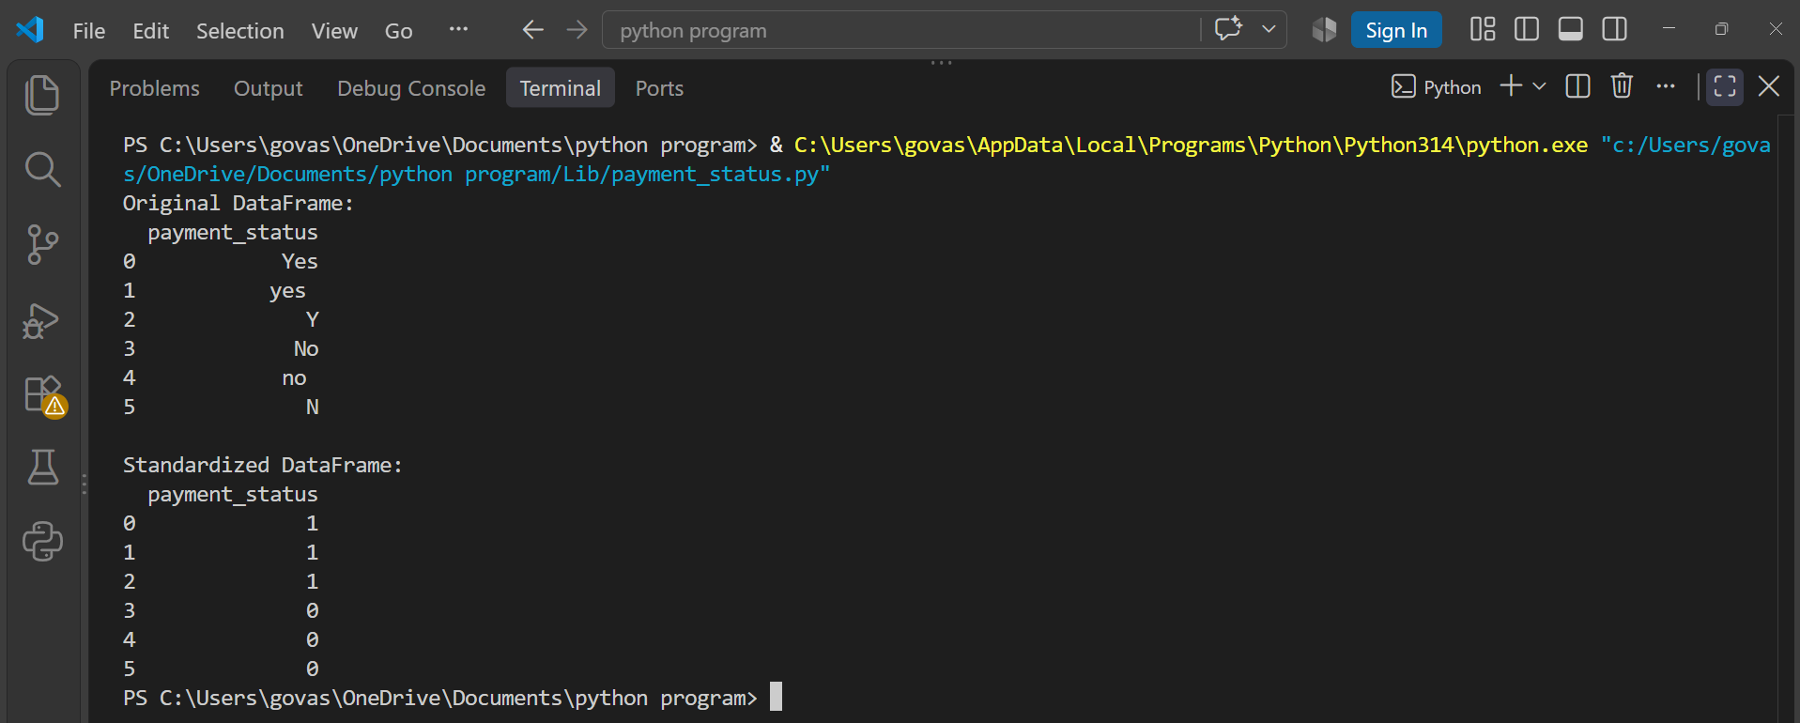
print(df)

